Book Scnerios

Get Book by id

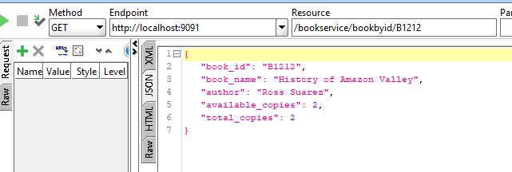

When Subscriber return /subscribe the book. This method is called to plus / minus the book availability count

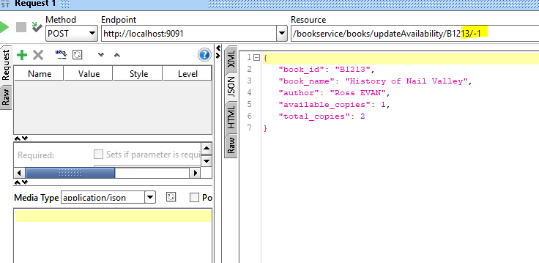

Book Subscribed

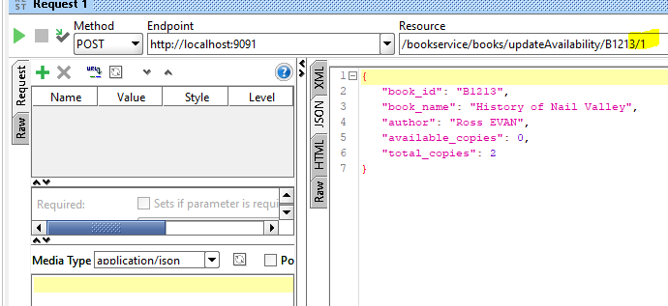

Book Return

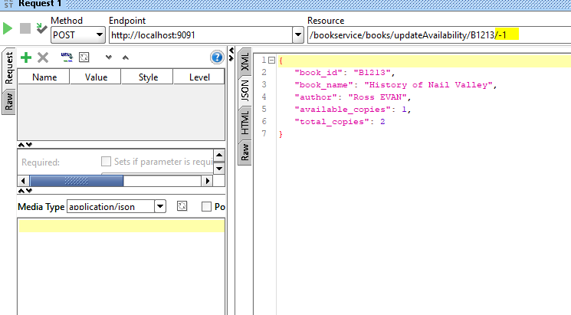

APIGateway

http://localhost:9000/Librarybspi/bookservice/bookbyid/B1212

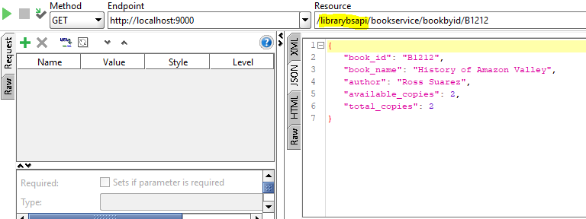

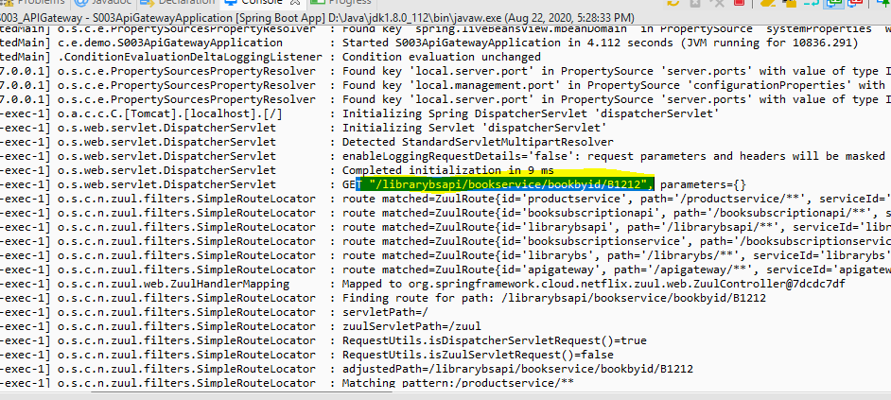

Book Service logs

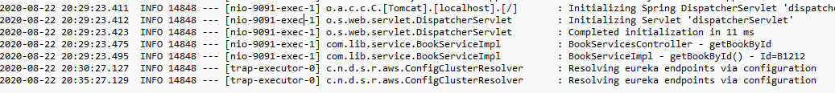

Call UpdateAvailability via APIgateway

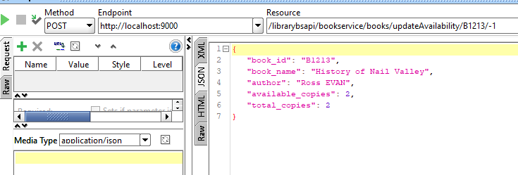

APIGateway logs

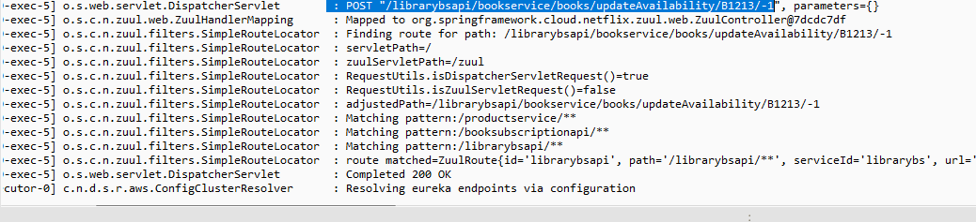

BookService logs

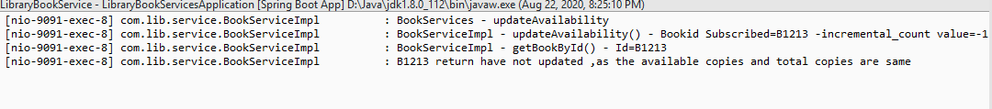

Kafka Implementation

Book available copies is Zero

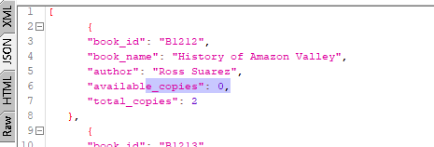

User Subscribe for book and notify flag=’Yes’

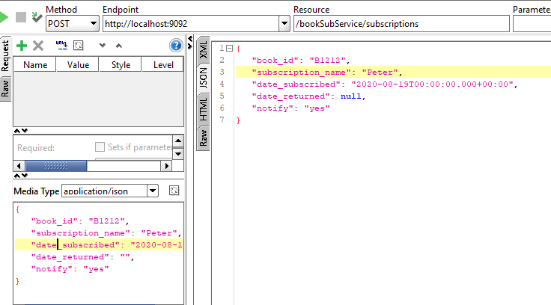

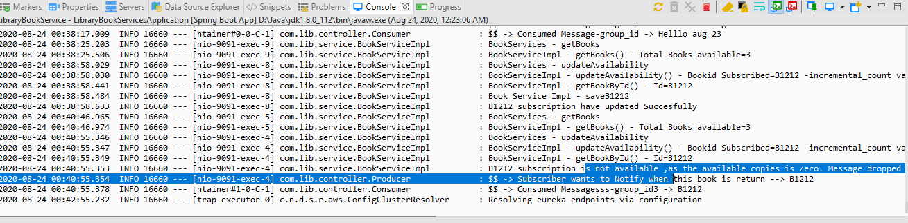

Book Return

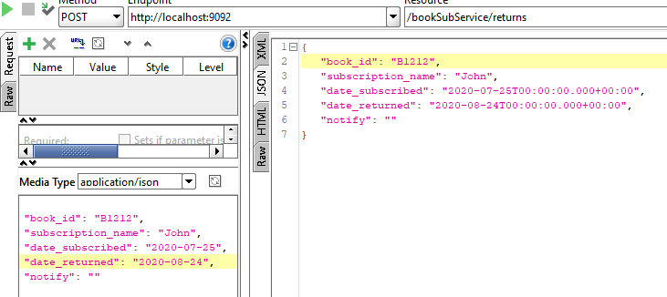

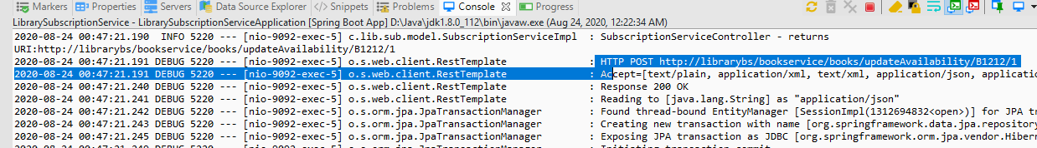

During return, read the message from topic for specific bookid

